**OSH AUTHORITIES - ITALY**

Source: <https://oshwiki.eu/wiki/OSH_system_at_national_level_-_Italy>

* **OSH Infrastructure**

**Scheme**

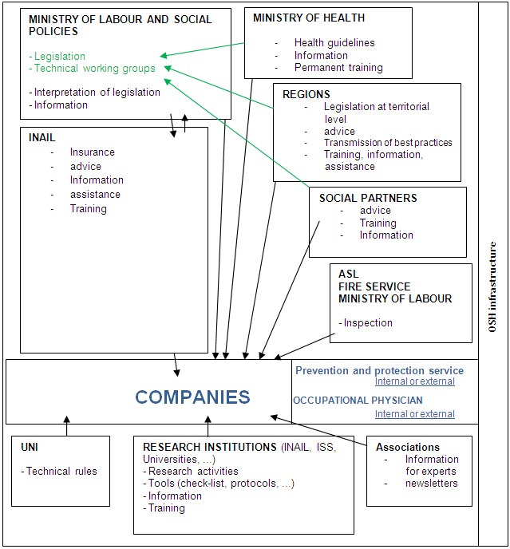

* **OSH auth****orities and inspection services**

|  |  |
| --- | --- |
| Name of the Authority | The Ministry of Labour and Social Policies |
| Link | <http://www.lavoro.gov.it/> |
| Short abstract | The Ministry of Labour and Social Policies, in line with the provisions laid down in Legislative Decree n. 81 of April 9th 2008, is committed to build and disseminate safety and prevention culture, giving higher importance to all activities and initiatives contributing to promote responsible and self-aware behaviors in workers, addressed not only to one’s own safety but also of others, and to identify strategies aimed at effectively fighting against the occurrence of accidents at work. With regard to that, the Ministry, sustained by an ongoing dialogue with social actors working every day on the ground of a concrete implementation of safety rules, in addition to proceeding on the legal side to finalise the reform of the regulation in force in this sector, also carries on its monitoring action of the implementation process and the situation of the provisions in force; such an action is aimed at examining relevant implementation issues and, in view of this, to develop interventions and actions aimed at improving the same regulation.  In such a context, the competences of Division III and VI of the General Direction of Working Conditions Protection fall within this scope (whose competences were included in the current General Direction of industrial relations and labour relationships.  Division III manages the procedures for the registration in qualified expert and authorized medical doctors lists, the Special Fund for Accidents for the financing of studies and research in the field of accidents and injuries; it provides for the collection and cataloguing of examination results carried on at the Provincial Directions of Labour concerning the qualification for handling and driving steam generators; it carries on consultancy activities relating to moral violence (so called “mobbing”) at workplace and collaborates at the organization of events and workshops on health and safety at work. Division VI works, in general, on all the profiles of health and safety of workers, in particular through the participation to European projects and preparation of texts for the implementation of relevant directives. In addition, it expresses opinions about the application of the regulation of reference with special regard to the Legislative Decree of April 9th 2008, no. 81 Implementation of the Article 1 of the Act no. 123, August 3rd, 2007, concerning the protection of health and safety at workplaces (workplaces, use of equipment and personal protection equipment, etc.); it provides for the authentication of a “personal book of radioprotection” for workers exposed to ionizing radiation risk; it manages the permanent advisory committee for health and safety at work.  The inspection staff of the Ministry of Labour and Social Policies performs an inspection activity on the implementation of legislation concerning health and safety at work in the following activities, in the framework of the territorial coordination provided by regional Committees:  a) Activities in the sector of building, construction and civil engineering and, more in particular, works of construction, maintenance, repair, demolition, preservation and renovation of stable, permanent or temporary manufacts, both in armed concrete and brickwork, road works, railway works, hydraulic works, excavations, assembling and disassembling of pre-manufactured elements; subterranean and gallery works, including the use of explosives;  b) Works using compressed air containers and works to be carried out underwater;  c) Any other working activities involving particularly high risks. |
| Link to OSH wiki | <https://oshwiki.eu/wiki/OSH_system_at_national_level_-_Italy> |

|  |  |
| --- | --- |
| Name of the Authority | Ministry of Health |
| Link | <http://www.salute.gov.it/portale/home.html> |
| Short abstract | The General Directorate for prevention at the Ministry of Health performs, among others, the following functions: - Prevention of occupational diseases and accidents, including other health-related competences, as defined by the Legislative Decree 81, Implementation of the Article 1 of the Act no. 123, August 3rd, 2007, concerning the protection of health and safety at workplaces of April 9th, 2008. Prevention of exposure to chemical, physical and biological agents in the natural and living environment, in water for human consumption and in working environment. The functions of the Conference of Regions and Autonomous Provinces may be distinguished into 3 major priority areas: improving the connection to and the dialogue with the central State through the development of documents shared by the entire “system of regional Governments”; the establishment of a permanent interregional dialogue in order to disseminate best practices; the necessity of representing the “system of regional Governments” on an ongoing basis at the external and in the institutional relations In particular, the IX Commission on Education, Labour, Innovation and Research is competent in relation to: education and professional training, labour policies, safety at work, university and scientific research, professions. Inspection services According to the provisions laid down in Art. 13 of legislative Decree no. 81/2008 Legislative decree no. 81, April 9th 2008, Implementation of the Article 1 of the Act no. 123, August 3rd, 2007, concerning the protection of health and safety at workplaces, the inspection services on compliance with safety and health regulations are carried on by ASL, which are competent on the territory and, as for its specific competence, by the national Fire brigade department. |
| Link to OSH wiki | <https://oshwiki.eu/wiki/OSH_system_at_national_level_-_Italy> |

Internal link to enforcement indicator by MS

* **Compensation and Insurance bodies**

|  |  |
| --- | --- |
| Name of the Body | Italian Workers' Compensation Authority - Istituto Nazionale per l’assicurazione contro gli infortuni sul lavoro (INAIL) |
| Link | <https://www.inail.it> |
| Short abstract | INAIL, the Italian Workers’ compensation Authority, pursues a plurality of objectives: to reduce injury occurrence; to provide an insurance for workers carrying on activities at risk; to guarantee the reinsertion of injured workers in the working life. The protection of workers, also in the light of the recent law developments, has assumed an ever more character of integrated system of protection, stretching from prevention actions at workplaces, to health and economic benefits, care, rehabilitation and reinsertion in social and occupational life in the case of workers who suffered from physical injuries due to accidents at workplace or occupational diseases. In order to reduce accidents, INAIL carries on important actions aimed at monitoring, on an ongoing basis, the employment and accident trend, training and assistance to small and medium enterprises in relation to prevention and funding of companies investing in the improvement of safety. |
| Link to OSH wiki | <https://oshwiki.eu/wiki/OSH_system_at_national_level_-_Italy> |

* **Research institutes**

|  |  |
| --- | --- |
| Name of the institute | Italian Workers' Compensation Authority - Istituto Nazionale per l’assicurazione contro gli infortuni sul lavoro (INAIL) |
| Link | <https://www.inail.it> |
| Short abstract | The Act no. 122 of July 30th, 2010 states the assignment to INAIL of the functions formerly carried on by ISPESL(Istituto Superiore per la Prevenzione e la Sicurezza sul Lavoro - National Institute for prevention and safety at work) in the field of technical-scientific activites, research, experimentation, control, consultancy, assistance and higher training. Accidents prevention , occupational safety, protection of health in living and working environments, training and promotion of safety culture are the main issues dealt with in the research projects that the Institution performs and/or finances. Other functions include the activites of first verification, verification of first set up of work equipment under this regime and random verification of putting to earth and protection against atmospherical discharge in all working activities; certification and acknowledgement of laboratories and certification bodies provided by European regulation and international agreements, as well as inspection and control of industries at risk of severe accidents in relation to specific activites. In the area of market control, the Institute performs controls, on behalf of the Ministry for Economic Development, of conformity to safety and health requirements for products used by workers; as Notified Body it issues, also through its local departments, declarations of conformity to the PED, TPED, SVP, ATEX European Directives. Research in the field of occupational safety is also carried on by Universities and ISS (Istituto Superiore di Sanità -National Health Institute). |
| Link to OSH wiki | <https://oshwiki.eu/wiki/OSH_system_at_national_level_-_Italy> |

* **Prevention Institutes**

|  |  |
| --- | --- |
| Name of the institute | Italian Workers' Compensation Authority - Istituto Nazionale per l’assicurazione contro gli infortuni sul lavoro (INAIL) |
| Link | <https://www.inail.it> |
| Short abstract | The Act no. 122 of July 30th, 2010 states the assignment to INAIL of the functions formerly carried on by ISPESL(Istituto Superiore per la Prevenzione e la Sicurezza sul Lavoro - National Institute for prevention and safety at work) in the field of technical-scientific activites, research, experimentation, control, consultancy, assistance and higher training. Accidents prevention , occupational safety, protection of health in living and working environments, training and promotion of safety culture are the main issues dealt with in the research projects that the Institution performs and/or finances. Other functions include the activites of first verification, verification of first set up of work equipment under this regime and random verification of putting to earth and protection against atmospherical discharge in all working activities; certification and acknowledgement of laboratories and certification bodies provided by European regulation and international agreements, as well as inspection and control of industries at risk of severe accidents in relation to specific activites. In the area of market control, the Institute performs controls, on behalf of the Ministry for Economic Development, of conformity to safety and health requirements for products used by workers; as Notified Body it issues, also through its local departments, declarations of conformity to the PED, TPED, SVP, ATEX European Directives. Research in the field of occupational safety is also carried on by Universities and ISS (Istituto Superiore di Sanità -National Health Institute). |
| Link to OSH wiki | <https://oshwiki.eu/wiki/OSH_system_at_national_level_-_Italy> |

* **Standardization Bodies**

|  |  |
| --- | --- |
| Name of the Body | UNI – National Italian Unification Body, Ente Nazionale italiano di Unificazione |
| Link | <http://www.uni.com/> |
| Short abstract | UNI is a non-for-profit private association founded in 1921 and recognised by the State and the European Union; it studies, elaborates, approves and publishes the voluntary technical dispositions – the so-called “UNI standards” – in all industrial, commercial and service sectors (except the electrical and electrotechnical ones). UNI associates are enterprises, professionals, associations, public bodies, research centres and schools. UNI represents Italy at the European (CEN) and Worldwide (ISO) standard organisations. The purpose of this body is to define technical rules and standards to contribute to the improvement of efficiency and effectiveness of the Italian social and economical system, by supporting tools for technological innovation, competitiveness, promotion of trade, protection of consumers and environment, product and process quality. |
| Link to OSH wiki | <https://oshwiki.eu/wiki/OSH_system_at_national_level_-_Italy> |